

Hand Held Terminal G-8I:
APPLICATION  THAT  EMPOWER | 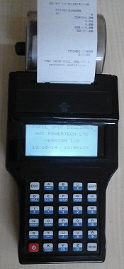

Overview:
M-8 a mobile handheld data capture, billing and Collection terminal to process and transmit information to host computers in real time. The simple user friendly design allows you to operate with easy and light weight and handy. Inbuilt impact printer high clarity graphic LCD display and keypad with good user interface. The Stored data can be uploaded to a PC via USB/RS-232 serial interface and GSM/GPRS wireless interface. The Device transfers billing data on GPRS to application Server at central Data center in both PUSH &PULL manners without any manual intervention. The PC software will be used for restoring all required MIS reports in the System.

32 bit Processor
Thermal Management Printer
GSM/RS232/USB
Micro SD Card

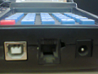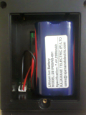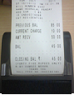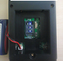

USB & RS232 Ports Battery Compartment Bill Printing SIM card Access

Features:  Built-in 2inch impact printer  Prints Barcode  Supports Two Different programmable Fonts  30 Keys Elastomeric designed keypad  Large bright graphical display  Self-diagnostic features  Compact and Comprehensive  Fast-Intelligent-Versatile-Affordable  Lithium-Ion rechargeable battery  User programmable  Easy paper loader | Application Areas:  - TIMS in Road transport  - Parking Management  - Retail outlet  - Police e- Challan  - Utility Meter Reading & Billing  - Tax Collection  - Field Data Collection  - LIC payment collection  - Receipt Printing  - Micro Finance  - Waste management collection  - Toll gate management.

Supporting Utilities:
- SDK with APIs

Specifications:
Processor | 32 bit RISC @ 120 MHz
Display | 128 x 64 pixel graphic FSTN LCD with backlight and configurable font
Memory | 512 KB Flash memory, 128 KB SRAM, 4MB data flash,
Printer | 2-inch Thermal Graphic Printer
Interface/Connectors | - RS-232 (RJ11 Connector for console / Serial port)  - USB Device (Type B)  - Micro SD Card holder for extendable memory size
Optional | - Custom Keypad  - Customized Software  - HF RFID Transceiver  - Blue tooth  - IRDA  - GSM/GPRS  - GPS  - 1D/2D Barcode Scanner
Power Adaptor | AC Input 100-240V ±30 %, 50Hz ±10%, DC output 10.5V, 2.5Amp
Battery | Rechargeable Li-ion 7.4V/2.2Ah
Enclosure | ABS+PC
Temperature | Operating : 0degree C to 55degree C
Humidity | 95% RH non condensing
EMI/EMC and Type tests | Comply As per IEC /IS standards
Dimensions in mm | 320 x 108 x 90 ( L x w x H)
Weight | 700 gms

System Concept and Architecture Diagram:


FIRE WALL
WEB SERVER
DATABASE
SERVER
Circle wise APPLICATION
SERVERS
HANDHELD
DEVICE
USER

GVM Electronic Systems.

Registered office:  502, Sri sai land mark, Block-A  Street No-8,Habsiguda  Hyderabad - 500007,  Telangana (INDIA).  Website : www.gvmgroup.co.in |  | R&D Center:  1-7-9/3, Level 1 Harihara Estates,  Opp ISI, Street No. 8,Habsiguda,  Hyderabad - 500007  Andhra Pradesh (INDIA)  Tel : 040 – 40073218.

